**FSN21218P: Analysis of Foodborne Pathogens**

**Objectives:**

This course will expose learners to

* Techniques of isolating bacteria and identifying bacteria;
* Methods of antibiotic sensitivity testing and viable microbial count in food.

**Learning Outcomes:**

Upon completion of this course, the learners would be able to

* Isolate and identify bacteria;
* Test antibiotics sensitivity against pathogens;
* Count viable microbes in food.

**Content:**

1. Aseptic culture technique

2. Method of isolation of pure culture

3. Identification of bacteria by Gram-staining

4. Antibiotics sensitivity testing

5. Isolation and identification of common food borne pathogens.

6. Determination of number of viable microorganisms in food sample.

7. Microbial testing of water

Introduction

Microbiology is the branch of biology that deals with the study of microorganisms, which are microscopic organisms such as bacteria, viruses, fungi, Achaea, and protists.Different kind of live microscopic organism are discussed in microbiology. Living organism are divided into 5 kingdoms on the basis of complexity of cell, complexity of organism, mode of nutrition. From which bacteria, protozoa, fungi and algae are commonly discussed in microbiology.

1. complexity of cell: Prokaryotes and Eukaryotes
2. complexity of organism: Unicellular, Multicellular
3. Mode of Nutrition: Autotrophic (photosynthesis) plant, saprophytic (absorption form dead body) fungus, heterotrophic (invective) Animal.

Cell wall present

Can’t perform photosynthesis

No organized nucleus

Cell wall present

Can perform photosynthesis

No cell wall

Eukaryotes other than fungi, algae, animalia

**Common microorganism responsible for food spoilage:**

* **Bacteria:**
* *Gram-negative bacteria:* Pseudomonas, Salmonella, Escherichia coli (E. coli)
* *Gram-positive bacteria:* Bacillus, Clostridium, Lactobacillus
* **Molds:**
* *Aspergillus species:* A. flavus, A. niger
* *Penicillium species:* P. roqueforti, P. camemberti
* *Rhizopus species:* R. stolonifer
* **Yeasts:**

1. *Saccharomyces cerevisiae*
2. *Candida species:* C. albicans, C. tropicalis

**Microbiology Lab equipment:**

1. Microscope
2. Incubator
3. Autoclave
4. Centrifuge
5. Biosafety Cabinet
6. Sprit lamp/ Bunsen Burner
7. pH Meter
8. Petri Dishes
9. Inoculation Loop
10. Micropipettes
11. Microbial Identification Systems
12. PCR Machine (Thermal Cycler)
13. Gel Electrophoresis Equipment
14. Microbial Fermenters
15. Different kind of media ingredients

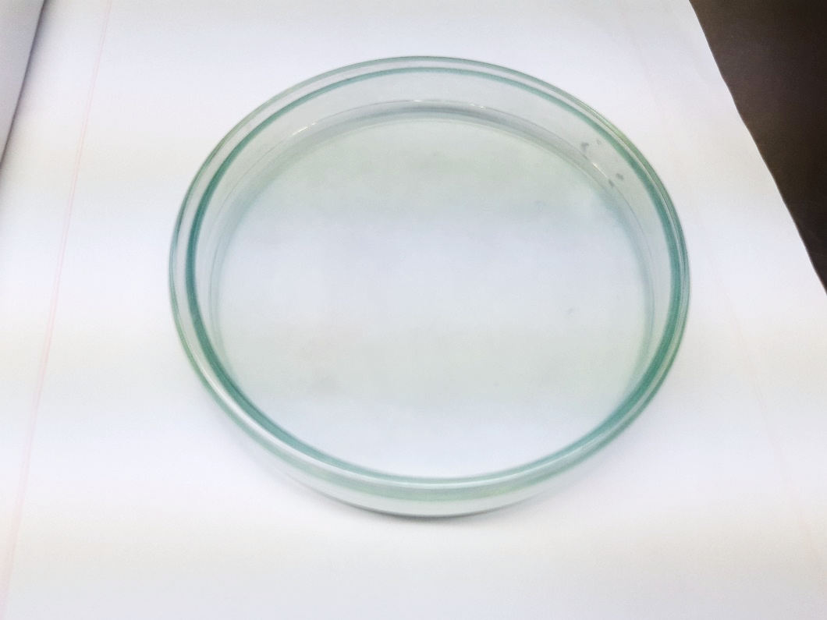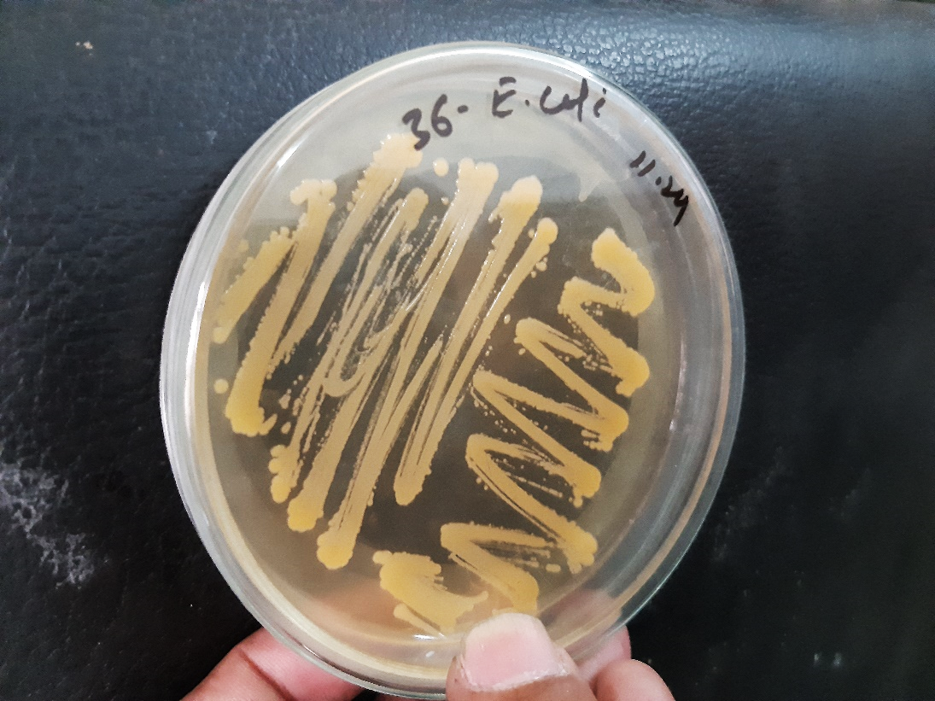

Petri dishes (Used for culturing and isolating microorganisms on solid media)

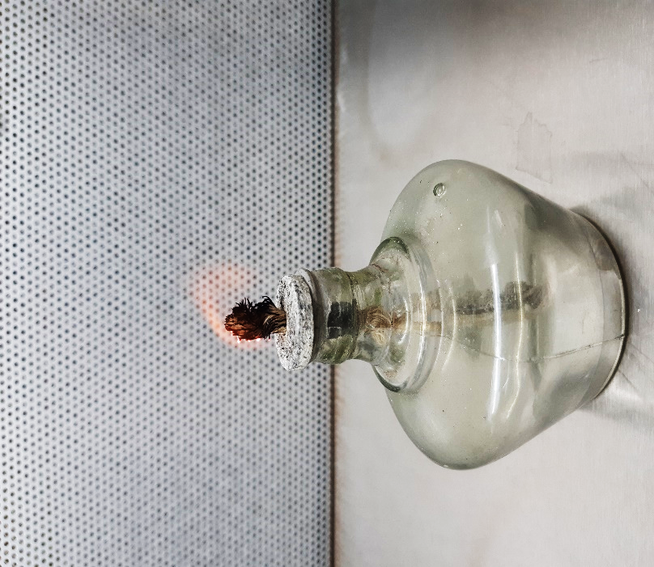 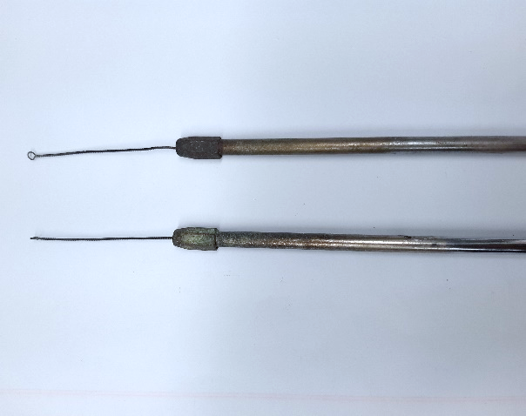

Inoculation loop (Used for transferring and streaking microorganisms onto culture media)

Spirit lamp (Used for sterilizing tools and the opening of culture tubes and petri dishes by flaming)

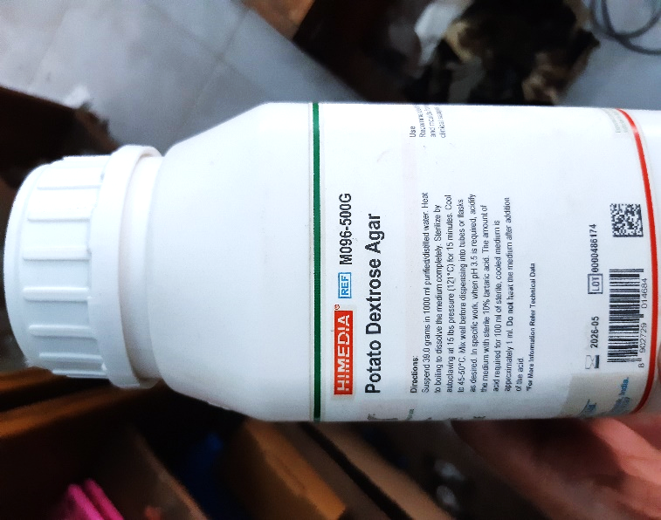 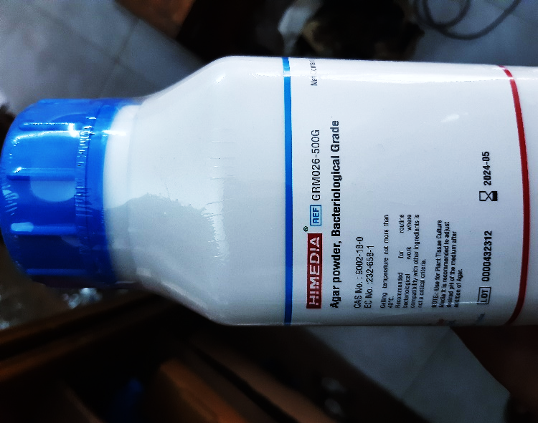

Media ingredients

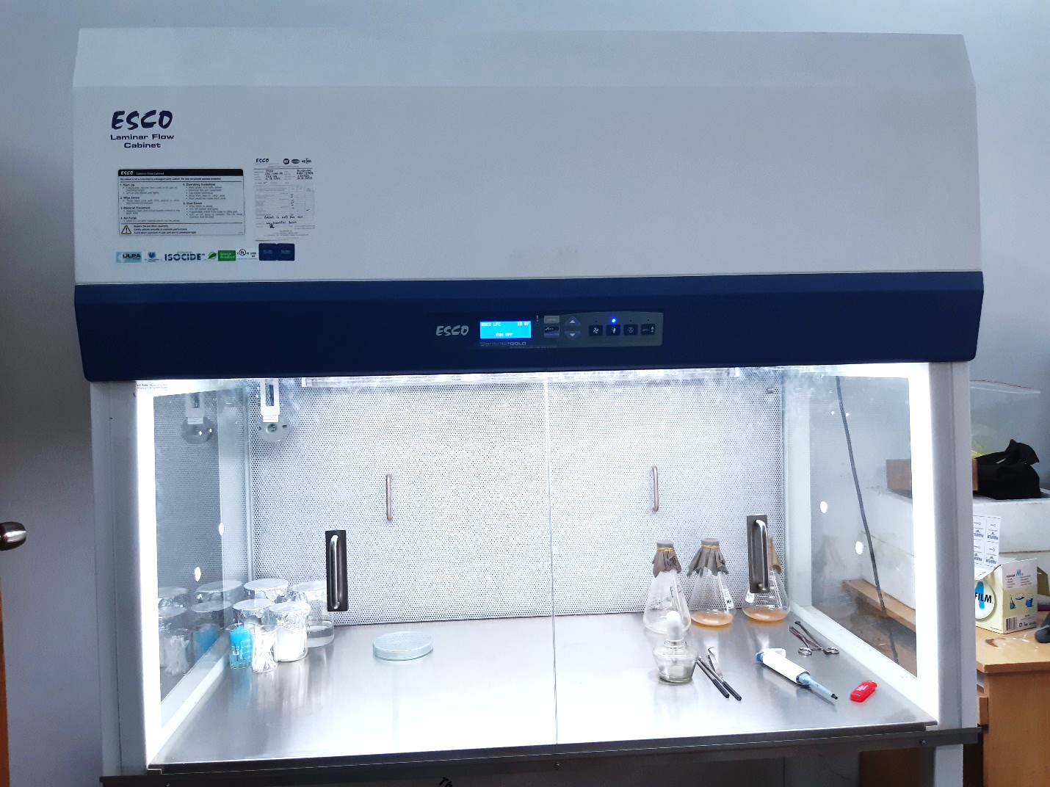

Biosafety Cabinet (Provides a sterile and enclosed environment for handling potentially hazardous microorganisms)

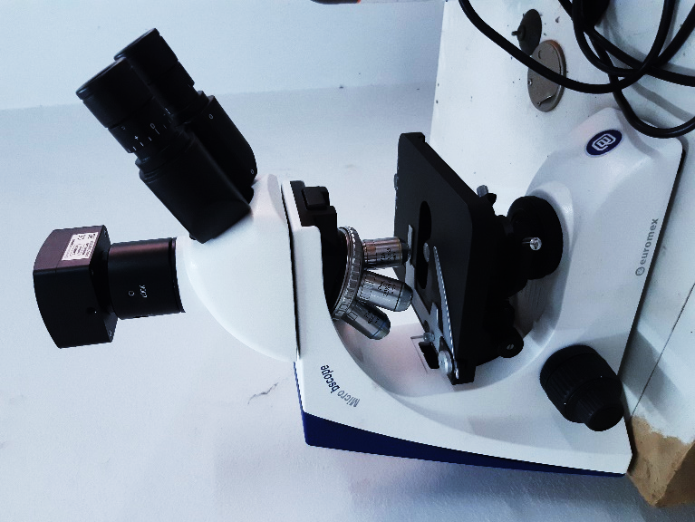

Microscope

Used for observing small specimens or cells at high magnification

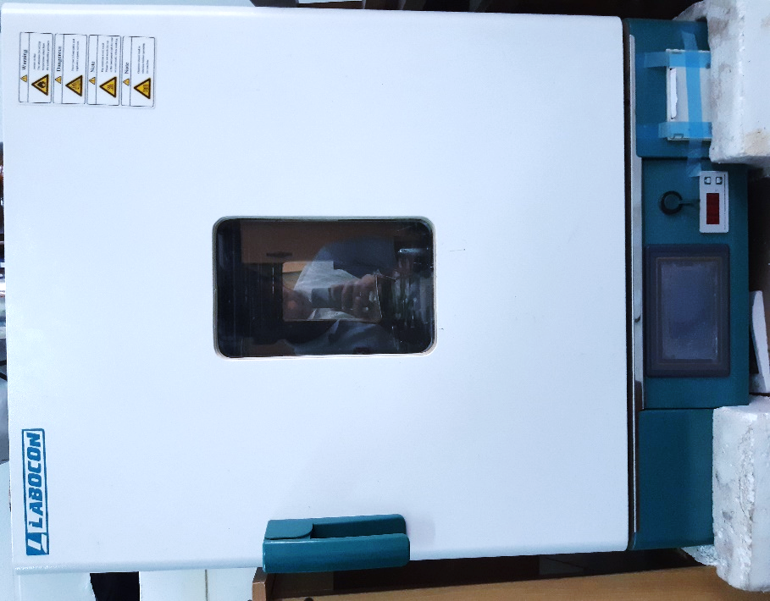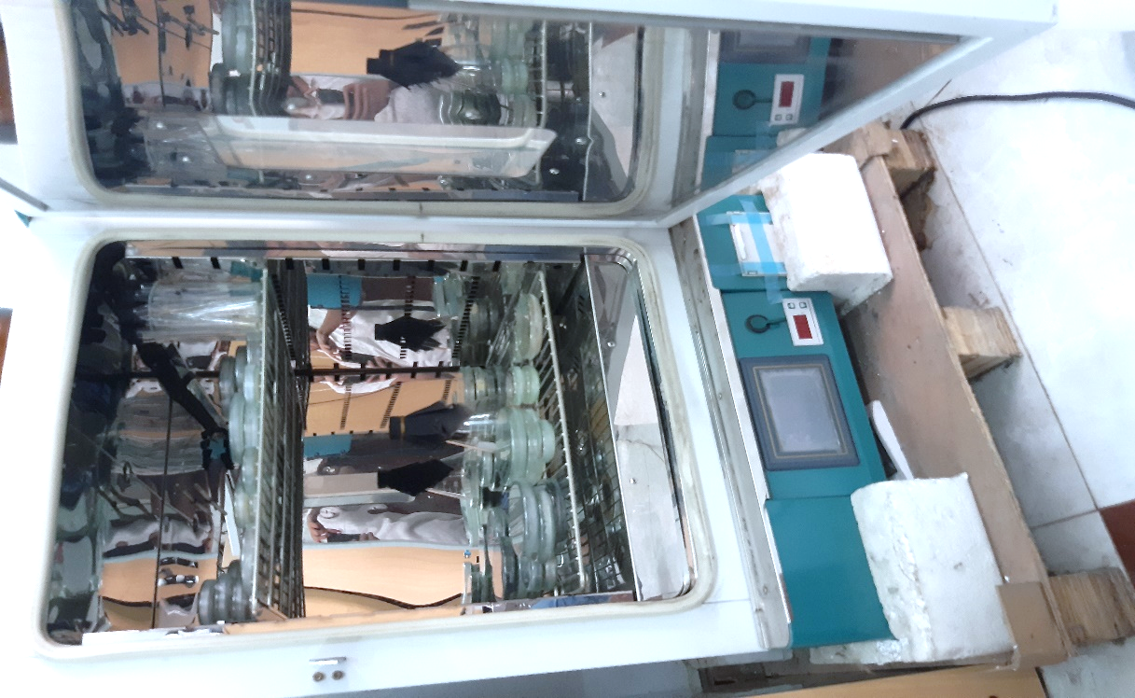

Incubator (Maintain controlled temperature and humidity for the cultivation and growth of microorganisms)

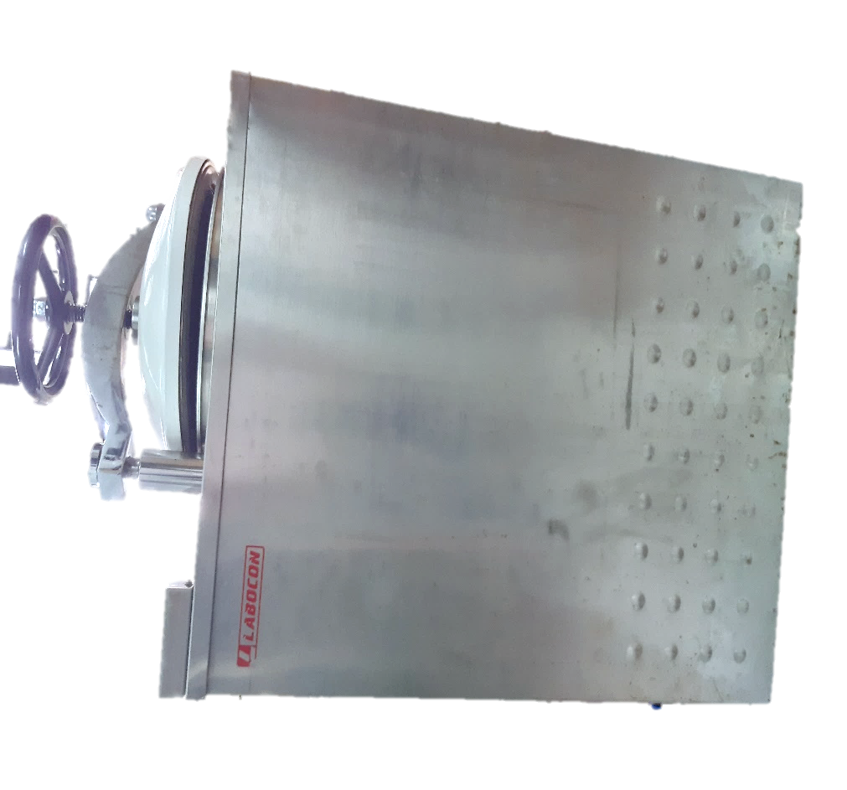

Autoclave

Sterilization equipment that uses high-pressure steam to kill bacteria, viruses, fungi, and spores on lab equipment and media

Culture Media

The food materials on which the organism is grown is known as culture medium and the growth of organism is known as culture. Different microorganisms require different nutrient materials. Thus, culture media vary in form and composition, depending upon the species to be cultivated.

**Basic Requirements of Culture Medium**

* Energy source
* Carbon source
* Nitrogen source
* Salts
* Adequate oxidation
* Growth factors

**Common Ingredients of Culture Media**

1. Water: Essential for existence of living cells.
2. Peptone: Obtained from meat, casein fibrin or soya flour. Acts as nitrogen source, carbon source, buffers
3. Meat Extract: Contains protein degradation products, carbohydrates. Source of growth factors (Vitamin B), inorganic salts etc.
4. Yeast Extract: Contains proteins, amino acids, growth factors (Vitamin B), Carbohydrates and inorganic salts like potassium and phosphates.
5. Electrolyte: Mainly used are sodium chloride or other electrolytes. Maintain the osmotic pressure
6. Agar: Dried mucilaginous substance obtained from gelidium and other algae; contains mainly long chain polysaccharides, protein like material and inorganic salts. Functions: it melts at 98 $℃$ and solidifies at 42 $℃$, hence used as solidifying agent.
7. Fermentable Compounds: Mainly used are sugars, alcohols etc. act as source of energy,
8. Buffers: Carbonates and phosphates are used as buffer to resist change in pH of the medium.

**Types of Media**

Based on consistency culture media can be classified as:

* 1. **Liquid Media or Broth:** No solidifying agents (e.g. agar) is added while preparing the medium. The most commonly used non-synthetic liquid media are nutrient broth, peptone solution, milk, blood, serum etc. Used for obtaining bacterial growth from blood or water when large volumes have to be tested.
  2. **Semi-Solid Media:** It is prepared by adding small amount of agar (0.5%) or gelatin. Agar forms a colloidal solution in hot water and sets in the form of a jelly when cool. This type of medium can be used to study bacterial motility
  3. **Solid Media:** It is prepared by adding 2% or 1% gelatin. It's used for colony characterization, colony identification, etc. e.g. Agar plates, slants, deeps.

**Based on purpose, culture media can be classified into:**

1. **Simple Media:** General-purpose medium used for the cultivation of a wide variety of microorganisms. E.g. Nutrient broth, nutrient agar
2. **Enriched Media:** Contains additional nutrients to support the growth of fastidious organisms. In these media, substances like blood, serum or egg are added. E.g. Blood agar, chocolate agar etc.
3. **Selective Media:** Contains inhibitors to select for the growth of specific groups of microorganisms. E.g. MacConkey agar, Mannitol Salt agar.
4. **Differential Media:** Allows for the differentiation of microorganisms based on their biochemical characteristics. E.g. Blood agar (hemolysis patterns), EMB agar (lactose fermentation).

Plating techniques

The common plating techniques employed in microbiology are Streak Plate Method, Spread Plate Method and Pour Plate Method.

1. **Streak Plate Method**

This method is routinely employed for the isolation of bacteria in pure culture. In this method a sterilized inoculating loop is dipped into a suitable diluted suspension of microorganisms which is then streaked on the surface of an already solidified agar plate to make a series of parallel, non-overlapping streaks.

The main objective of the streak plate method is to produce well separated colonies of bacteria from concentrated suspensions of cells.

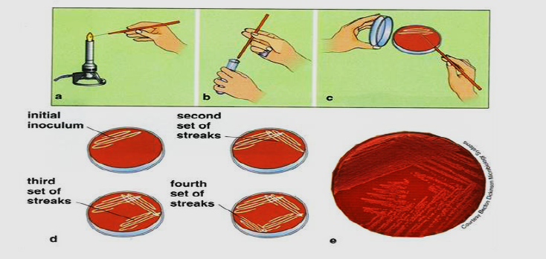

1. **Spread Plate Method**

The spread plate technique is used for the separation of a dilute, mixed population of the microorganisms so that individual colonies can be isolated. In this technique, a small volume of dilute microbial mixture is transferred to the center of an agar plate and spread evenly over the surface. The dispersed cells will develop into isolated colonies. Because the number of colonies will be equal to the number of viable organisms in the sample spread plates can be used to count the microbial population.

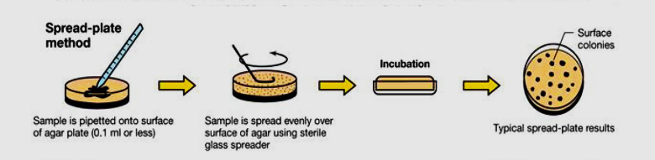

1. **Pour Plate Method**

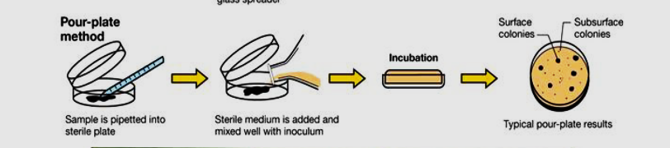

In pour plate method, successive dilutions of the inoculum (serially diluting the original specimen) are added into sterile petri plate to which is poured melted and cooled (420C - 450C) agar medium and thoroughly mixed by rotating the plates which is then allowed to solidify. After incubation, the plates are examined for the presence of individual colonies. The pure colonies may be isolated and transferred into test tube culture media for making pure cultures. This technique is employed to estimate the viable bacterial count in a suspension.

Spread Plate Technique for Colony Counting

The spread plate technique is a common method used in microbiology for isolating and quantifying microorganisms in a sample. This technique is particularly useful for determining the viable cell count (number of live cells) in a liquid sample. Colony counting is often performed on solid agar medium using the spread plate technique.

**Materials and Equipment:**

1. Agar plates containing a suitable growth medium
2. Sterile pipettes or micropipettes
3. Sterile spreader or glass rod
4. Sterile distilled water or saline solution
5. Bunsen burner or alcohol burner
6. Inoculating loop or sterile pipette tips
7. Microbial sample to be analyzed

**Procedure:**

1. **Prepare Agar Plates:**

* Take weight of agar media and mix with distilled water following the label on media container.
* Sterile the media and petri dishes by autoclaving at 121 $℃$ and 100KPa pressure for 15 minutes
* Pour the hot media in sterile petri dishes aseptically inside biosafety cabinet and allow it to solidify.

1. **Label the Plates:**

* Label the bottom of each agar plate with the necessary information, such as the date, sample ID, and dilution factor.

1. **Dilution of the Sample:**

* If the sample is expected to have a high microbial count, perform serial dilutions by transferring known volumes of the sample into tubes containing sterile diluent (e.g., saline or sterile water).
* Mix the dilutions thoroughly.

1. **Inoculation:**

* Clean the biosafety cabinet properly with disinfectant (70% ethanol)
* Sterilize the spreading device (spreader or glass rod) by spraying 70% ethanol and flaming it with the Bunsen burner.
* Take a small volume (usually 0.1 mL) of the diluted sample using a sterile pipette or inoculating loop.
* Spread the sample evenly over the surface of the solid agar medium by gently moving the spreader or glass rod back and forth.

1. **Incubation:**

* Allow the agar plates to dry for a few minutes before placing them in an incubator.
* Incubate the plates at the appropriate temperature and conditions for the microorganisms being analyzed.

1. **Colonies Development:**

* After incubation (usually 24-48 hours), colonies will appear on the agar surface.
* Each colony arises from a single viable cell present in the original sample.

1. **Colony Counting:**

* Use a colony counter or manual counting method to count the individual colonies on the plates.
* Report the results as colony-forming units per milliliter (CFU/mL) based on the dilution factor.

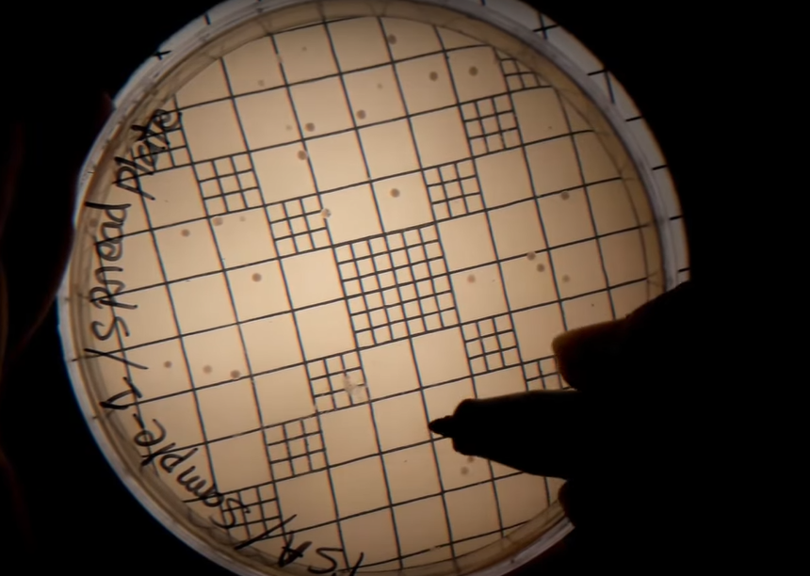

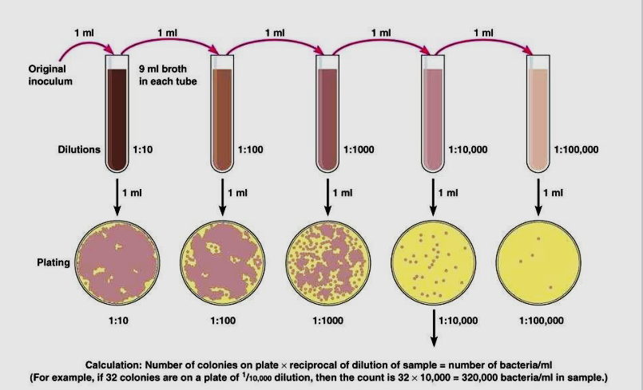

Isolating a pure culture

Isolating a pure culture involves separating a single species of microorganism from a mixed culture, allowing researchers to study it in a controlled environment. The streak plate method is a commonly used technique for isolating pure cultures.

**Materials required:**

1. Incubator
2. Biosafety Cabinet
3. Sprit lamp/ Bunsen Burner
4. Petri Dishes
5. Inoculation Loop
6. Colony counter

**Procedure:** The process generally involves the following steps:

1. **Preparation of culture media:** Take weight of agar media and mix with distilled water following the label on media container. Sterile the media by autoclaving at 121 $℃$ and 100KPa pressure for 15 minutes.
2. Clean the biosafety cabinet properly with disinfectant. Pour the hot media in sterile petri dishes aseptically inside biosafety cabinet. Wait for few minutes allowing the agar media to cool and solidify then cover the dish with lid.
3. Burn a burner with firebox carefully and sterile the loop by burning to red hot.
4. After cooling the inoculating loop pick up one loop full of bacterial culture from the culture plate and make a smear with the culture of a corner of the fresh plate.
5. Burn the loop to red hot again to make it sterile. Wait to cool the loop at room temperature. After cooling take the loop and start streaking in zigzag style on first quarter of the plate touching the smear.
6. Close the plate and burn the loop again as done previously. After burning cool the inoculation loop and again streak on second quarter on the plate.
7. Streak on the third and fourth quarter without burning the loop.
8. Finish the streaking and cover the newly inoculated plate with lid. Lebel the sample name, date and method.
9. **Incubation:** Invert the plate and incubate at 37 $℃$ for 24 hours.
10. After incubation take out the plate from the incubator, you can see many isolated bacterial colonies in third and fourth quarter area. These are pure colonies which we have got from test.
11. Pick an isolated colony from this plate and culture it in another fresh by streaking method to get a pure culture of the bacteria.

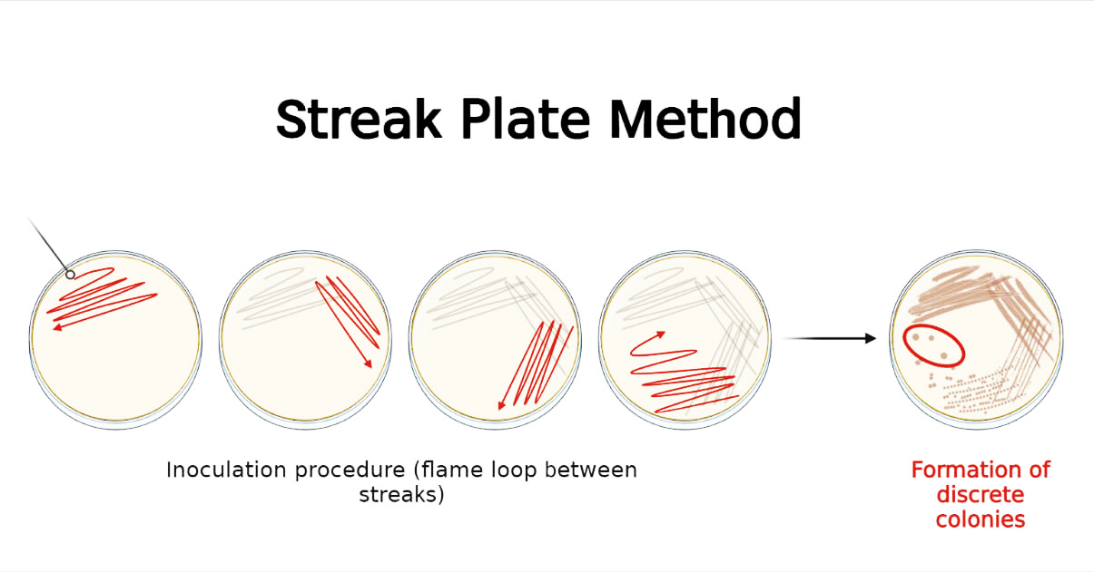

Antibiotic sensitivity testing

The disk diffusion method is a common technique used to assess the antibacterial activity of a substance, such as an antibiotic or plant extract. This method provides a qualitative measure of the susceptibility of bacteria to a specific compound. Here's a step-by-step guide on how to perform the disk diffusion test:

**Materials and Equipment:**

1. Nutrient agar plates (or Mueller-Hinton agar for standardized testing)
2. Bacterial cultures (pure cultures of test organisms)
3. Sterile cotton swabs or inoculating loops
4. Antibiotic disks or paper disks impregnated with the substance being tested
5. Sterile forceps
6. A ruler or calipers
7. Incubator set to appropriate temperature (usually 35-37°C)
8. Sterile distilled water or saline (for suspension preparation)
9. Mueller-Hinton agar plates (for standardized testing)
10. Bunsen burner or alcohol burner
11. Disposal container for used materials

**Procedure:**

1. **Preparation of culture media:** Take weight of agar media and mix with distilled water following the label on media container. Sterile the media, petri dishes and cotton buds by autoclaving at 121 $℃$ and 100KPa pressure for 15 minutes.
2. Clean the biosafety cabinet properly with disinfectant. Pour the hot media in sterile petri dishes aseptically inside biosafety cabinet. Wait for few minutes allowing the agar media to cool and solidify then cover the dish with lid.
3. **Preparation of Inoculum:**
4. Select the test bacterial strains. These could be clinical isolates or standard strains.
5. Prepare a bacterial suspension equivalent to a 0.5 McFarland standard.
6. **Inoculation of Agar Plates:** Using a sterile cotton bud, streak the bacterial suspension evenly over the surface of the agar plate. Allow the inoculum to dry for a few minutes.
7. **Placement of Disks:** Using sterile forceps, place the antibiotic disks onto the surface of the inoculated agar plates. Apply gentle pressure to ensure good contact between the disks and the agar surface.
8. **Incubation:** Incubate the plates at the appropriate temperature (usually 35-37°C) for 16-18 hours.
9. **Measurement of Zones of Inhibition:** After incubation, observe the plates for the presence of clear zones (areas without bacterial growth) around the disks. Measure the diameter of each zone of inhibition using a ruler or calipers.
10. **Interpretation:** Compare the diameter of the zones of inhibition with established standards or guidelines for specific antibiotics or substances. Larger zones generally indicate greater antibacterial activity.
11. **Controls:**
12. Include positive controls with known susceptible bacteria and known antibiotic disks for validation.
13. Include negative controls, such as disks with sterile water, to ensure that observed effects are due to the tested substance.

The disk diffusion method is a qualitative test, and the results should be interpreted in the context of established standards or guidelines. It's important to note that the method provides information on the sensitivity of bacteria to a substance but does not provide quantitative data on the minimum inhibitory concentration (MIC).

While the **McFarland standard** is traditionally assessed visually by turbidity, if you prefer a more quantitative measurement using a colorimeter or spectrophotometer, you can determine the optical density (OD) of the bacterial suspension at a specific wavelength. The optical density is directly related to the turbidity of the solution.

Here's how you can adapt the preparation of a 0.5 McFarland standard for a colorimetric measurement:

1. **Prepare Saline Solution:**

* Use a physiological saline solution (0.85% NaCl).
* Sterilize the saline solution by autoclaving or using commercially available sterile saline.

1. **Prepare Bacterial Suspension:**

* Inoculate the saline solution with the bacterial culture.
* Incubate the bacterial suspension until it reaches the desired turbidity or optical density.

1. **Measure Optical Density:**

* Using a colorimeter or spectrophotometer, measure the optical density of the bacterial suspension at a specific wavelength (commonly 600 nm).
* The optical density should correspond to the standardized McFarland turbidity.

1. **Adjust if Necessary:**

* If the measured optical density does not match the desired 0.5 McFarland standard, you may need to dilute or concentrate the bacterial suspension and recheck until it aligns with the standard.

1. **Conversion to McFarland Units:**

* Some laboratories prefer to convert the optical density readings to McFarland units using a calibration curve. A calibration curve is generated by correlating optical density readings with known McFarland standards.

**Steps in part-1**

Step-01: culture media preparation

Step-02: sample preparation

Step-03: non-selective enrichment

Step-04: selective enrichment

Step-05: isolation of bacteria

Step-06: selection of bacteria

**Culture Media preparation**

1. Bismuth bisulphite agar (BSA)
2. Rappaport Vassiliadis soy broth (RSV)
3. MKTTn broth
4. X.L.D Agar

**Xylose Lysine Deoxycholate (XLD) Agar**

1. Dissolve 5.668g XLD Agar powder into 100ml distilled Water.
2. Heat at boiling point for 2 minutes & stir to dissolve the medium completely.
3. Distribute 18ml into sterile petri dishes and cool to solidify.

**Bismuth Sulphite Agar (BSA)**

1. Dissolve 5.232g Bismuth Sulphite Agar powder into 100ml Distilled Water.
2. Heat at boiling point for 2 minutes & stir to dissolve the medium completely.
3. Distribute 18ml into sterile petri dishes and cool to solidify.

**Buffered Peptone Water (BPW)**

1. Dissolve 25.5g Buffered Peptone Water powder into 1000ml Distilled Water.
2. Autoclave at 1210C temperature and 15 lbs pressure for 15 minutes.

**Rappaport Vassiliadis Soya (RVS) Broth**

1. Dissolve 2.71g RVS Broth powder into 100ml Distilled Water.
2. Heat to dissolve the medium completely and distribute 10ml into Glass Test Tubes.
3. Sterile by autoclaving at 115 ℃ and 15 lbs pressure for 15 minutes.

**Muller-Kauffmann Tetrathionate Novobiocin (MKTTn) Broth**

1. Dissolve 89.4g MKTTn Broth powder into 1000ml Distilled Water.
2. Heat the Medium to Just Boiling and cool it at 45- 48℃. Add 1 vial of MKTTn supplement (FD203) and 20ml iodine-iodide Solution.
3. Distribute 10 ml into glass test tubes.

**Sample preparation**

1. Take about 25g sample into a sterile bag and label the bag with sample name.
2. Take the sample in a biosafety cabinet.
3. Measure 225 ml buffered peptone water aseptically and pour it into the bag.
4. Shake the bag to mix the content, vortex the mixture to homogenize the sample for 15 sec.
5. Now incubate the mixture at 37 ℃ for 24h for non-selective enrichment.

**Procedure:**

1. We will use RSV and MKTTn broth for selective enrichment of salmonella.
2. Shake the bag to mix the culture properly and transfer 1 ml buffered peptone water enrichment culture into MKTTn broth and attach the cap loosely.
3. Transfer 0.1 ml buffered peptone water enrichment culture into RSV broth and attach the cap loosely.
4. Now, vortex both test tube for 10 seconds and
5. Incubate the MKTTn broth at 37℃ and RSV broth at 41.5℃ for 24 h for selective enrichment.
6. After incubation, take out RSV and MKTTn broth cultures.
7. Now streaking from RVS Enrichment on BSA Plate for Trial-1 and Trial-2 plates.
8. Streaking from RVS Enrichment on XLD Plate for Trial-I and Trial-2 plates.
9. Streaking from MKTTn enrichment on BSA plate and XLD plate.
10. Now incubate the inoculated XLD & BSA plates at 37℃ for 24.

**Observation:**

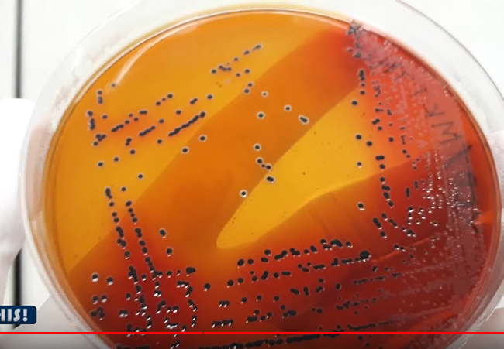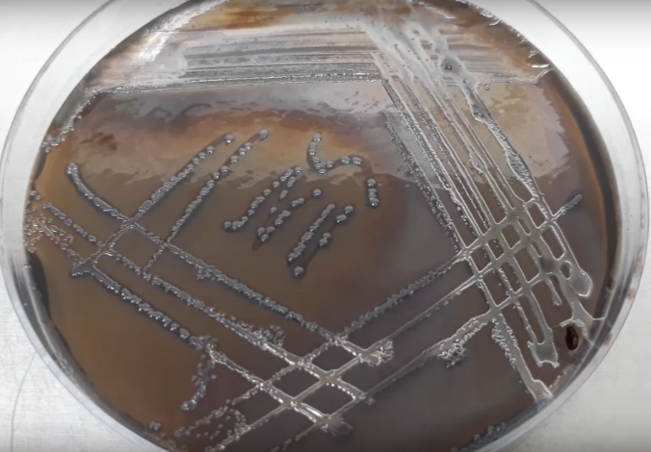

|  |  |
| --- | --- |
| *Black colonies on XLD plate are primarily considered as Salmonella spp.* | *Black to grey colonies turned the BSA media color into black. These black or grey colonies are primarily considered as salmonella spp.* |

**Part 2: Biochemical Identification**

Step-01: media preparation

Step-02: reagent preparation

Step-03: pure culture preparation

Step-04: biochemical tests

Step-05: result observation

Step-06: result interpretation

**Required Medias**

1. Triple Sugar Iron (TSI) Agar
2. MR-VP Medium
3. Simmon Citrate Agar
4. LIM Medium
5. Urea Agar

**Reagents**

1. For Indole Test Kovacs Reagent: Commercially prepared Kovacs Reagent is Available
2. For MR Test Methyl Red Solution: Dissolve 1g Methyl Red Indicator Powder into 100ml Ethanol
3. For VP Test 1-Napthanol Solution: Dissolve 1.2g of 1-Napthanol Powder into 20ml Ethanol.
4. For VP Test Potassium Hydroxide Solution: Dissolve 20g of Potassium Hydroxide Pellets into 50ml Distilled Water.
5. For VP test Creatine Solution: Dissolve 0.5g Creatine Monohydrate into 100ml Distilled Water.

**Procedure**

1. Take 7 stoppered test tube with citrate agar, MR-VP medium, MIU agar, LIM medium, Urea agar and TSI agar.

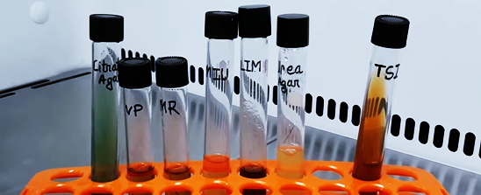

1. Streak Black Colonies on TSA Plate from XLD Culture plate.
2. Streak Black Colonies on TSA Plate from BSA Culture Plate.
3. Now incubate the inoculated TSA plates at 37°C for 24 hours.
4. Inoculate the MR-VP medium with the suspected Salmonella colony for MR test. Attach the cap and rotate the tube to mix the content.
5. Inoculate the MR-VP medium with the suspected Salmonella colony for VP test. Attach the cap and rotate the tube to mix the content.
6. 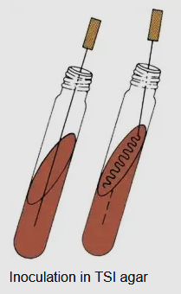Inoculate the slant & butt of TSI with the suspected Salmonella colony. Stub into the butt and then streak on the slant surface of TSI Agar then attach the cap.
7. Inoculate the slant & butt of Simmon citrate Agar with the suspected Salmonella colony. Stub into the butt and then streak on the slant surface.
8. Now stub into the MIU medium without disturbing the surrounding media for motility, indole and urea test.
9. Now stub into the LIM medium to inoculate it for lysin decarboxylation test.
10. Now stub into the Urea Agar medium to inoculate it for urea utilization test.
11. Loose the cap and incubate all of the inoculated tubes at 37°C for 24 hours.

**Observation:**

1. **TSI:** Black color butt is formed due to hydrogen sullite formation and slant turned into red due to dextrose fermentation. The medium is lifted-up from the bottom due to the gas production.

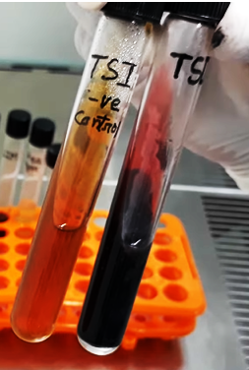

1. **LIM:** The media color is turned into purplish. So. the bacteria showed positive reaction for this test.

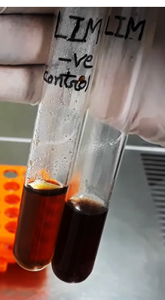

1. **SCA:** The media color is turned into blue from green. So, the bacteria is Citrate positive

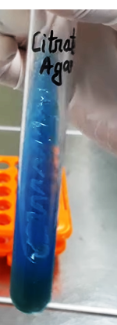

1. **MUI**: Media colour is not turned into pink. So, the bacteria is urea negative. Growth pattern shows the bacterial growth is spread out throughout the media outside of the stub-line. That's why the bacteria is motile. Now, add few drops of Kovacs reagent. No cherry ring is found indicating that the bacteria is indole negative

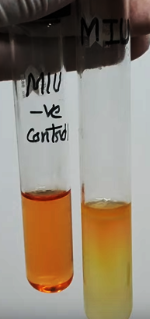

1. **Urea Agar:** No pink color is formed in the Urea Agar. So, the bacteria can't utilize Urea.

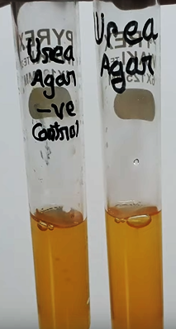

1. **MR:** Add few drops of methyl red solution into the MR tube. Red color development indicates that the bacteria is positive for MR test.

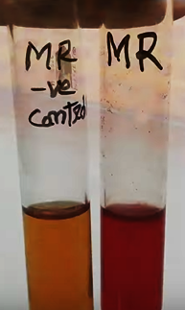

1. **VP:** Add 3 drops of creatine solution. Now, add 2 drops of 1-napthol and finally add 3 drops of potassium hydroxide solution. Close the tube with it's cap and shake slightly to mix the reagents. No pink or red color in 15 min indicates the bacteria is VP negative.

|  |  |  |  |  |  |  |  |  |  |
| --- | --- | --- | --- | --- | --- | --- | --- | --- | --- |
|  | TSI slant | H2S & Gas | Motility test | Indole test | Urea test | Lysine decarboxylase | Citrate Utilization | MR reaction | VP reaction |
| Typical salmonella spp. | Red | +ve | +ve | -ve | -ve | +ve | +ve | +ve | -ve |
| Suspected Bacteria | Red | +ve | +ve | -ve | -ve | +ve | +ve | +ve | -ve |

1. **Aseptic culture technique**

**Materials required:**

1. Distilled water
2. Conical flask
3. Measuring cylinder
4. Mular-Hilton agar media
5. Sprit lamp
6. Lighter
7. Inoculation loop
8. Petri dish
9. Disinfectant (70% Ethanol)

**Procedure**:

1. **Media preparation**: As directed by the media labeling, weigh the mular-hilton agar media. Pour it into a conical flask. Fill it with the necessary volume of water by using a measuring cylinder. Using a piece of cloth to close the conical flask, shake the contents to ensure thorough mixing.
2. **Sterilization**: To eradicate any existing microorganism, autoclave medias and equipment for 15 minutes at 121°C and 101 kPa pressure.
3. Use 70% ethanol to sanitize your hands and to clean the biosafety cabinet's floor. Close the cabinet’s door and turn on the UV lamp to kill any existing microorganisms.
4. After ten minutes, turn off the UV lamp and open the door. Turn on the fan, in order to prevent microorganisms from entering into the biosafety cabinet.
5. After sterilization is complete, remove media and equipment from the autoclave and store them in the biosafety cabinet.
6. Let petri dishes air dry, then close them once the drying process is finished.
7. Fire the spirit lamp, remove the media's covering and burn the top portion in the lamp's flame.
8. Next, fill the petri dish with media up to halfway and close them once the media is solidified.
9. Burn the top portion of inoculation loop over the lamp flame, then cool it by drowning it into the media.
10. Touch the inoculation loop onto the bacteria of another culture media and spread it into new media.
11. Seal the petri dish using paraflim and incubate at 37 $℃$ for 24 hour.

**Observation**

**Composition of Bismuth Sulphite Agar (BSA)**

|  |  |
| --- | --- |
| **Ingredients** | **Gms/liter** |
| Peptone | 10.000 |
| HM Peptone B # | 5.000 |
| Dextrose (Glucose) | 5.000 |
| Disodium phosphate | 4.000 |
| Ferrous sulfate | 0.300 |
| Bismuth sulfite indicator | 8.000 |
| Brilliant green | 0.025 |
| Agar | 20.000 |

**Result Interpretation of Bismuth Sulphite Agar (BSA)**

|  |  |
| --- | --- |
| **Organisms** | **Growth** |
| *Enterobacter aerogenes* | Poor growth; Brown-green (depends on the inoculum density) |
| *Enterococcus faecalis* | Inhibited |
| *Escherichia coli* | Poor growth; Brown-green (depends on the inoculum density) |
| *Salmonella* Enteritidis | Good-luxuriant growth; Black with a metallic sheen |
| *Salmonella* Typhi | Good-luxuriant growth; Black with a metallic sheen |
| *Salmonella* Typhimurium | Good-luxuriant growth; Black with a metallic sheen |
| *Salmonella* Abony | Good-luxuriant growth; Black with a metallic sheen |

**Composition of Triple Sugar Iron (TSI) Agar**

|  |  |
| --- | --- |
| **Ingredients** | **Gms/liter** |
| Pancreatic Digest of Casein | 15.0 |
| Lactose | 10.0 |
| Sucrose | 10.0 |
| Sodium Chloride | 5.0 |
| Peptic Digest of Animal Tissue | 5.0 |
| Yeast Extract | 3.0 |
| Beef Extract | 3.0 |
| Dextrose | 1.0 |
| Ferric Ammonium Citrate | 0.5 |
| Sodium Thiosulfate | 0.3 |
| Phenol Red | 0.024 |
| Agar | 12.0 |

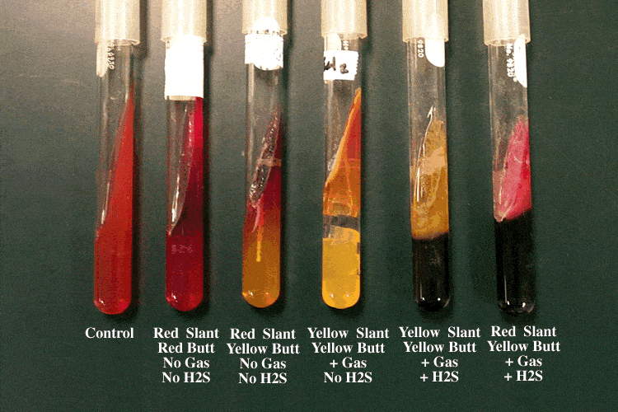

|  |  |  |
| --- | --- | --- |
| **Results (slant/butt)** | **Symbol** | **Interpretation** |
| Red/yellow | K/A | Glucose fermentation only; Peptone catabolized |
| Yellow/yellow | A/A | Glucose and lactose and/or sucrose fermentation |
| Red/red | K/K | No fermentation; Peptone catabolized |
| Red/no color change | K/NC | No fermentation; Peptone used aerobically |
| Yellow/yellow with bubbles | A/A,G | Glucose and lactose and/or sucrose fermentation; Gas produced |
| Red/yellow with bubbles | K/A,G | Glucose fermentation only; Gas produced |
| Red/yellow with bubbles and black precipitate | K/A,G, H2S | Glucose fermentation only; Gas produced; H2S produced |
| Red/yellow with black precipitate | K/A, H2S | Glucose fermentation only; H2S produced |
| Yellow/yellow with black precipitate | A/A, H2S | Glucose and lactose and/or sucrose fermentation; H2S produced |
| No change/no change | NC/NC | No fermentation |
| A=acid production; K=alkaline reaction; G=gas production; H2S=sulfur reduction | | |

|  |  |  |  |  |
| --- | --- | --- | --- | --- |
| **Name of the organism** | **Slant** | **Butt** | **Gas** | **H2S** |
| *Escherichia, Klebsiella, Enterobacter* | Acid (A) | Acid (A) | Pos (+) | Neg (-) |
| *Shigella, Serratia* | Alkaline (K) | Acid (A) | Neg (-) | Neg (-) |
| *Salmonella, Proteus* | Alkaline (K) | Acid (A) | Pos (+) | Pos (+) |
| *Pseudomonas* | Alkaline (K) | Alkaline (K) | Neg (-) | Neg (-) |

|  |  |
| --- | --- |
| **Organisms** | **Growth** |
| *Salmonella enterica* | Growth; red slant, yellow butt, gas positive, black-butt (H2S produced) |
| *Escherichia coli* | Growth; yellow slant, yellow butt, gas positive, no H2S produced |
| *Pseudomonas aeruginosa* | Growth; red slant, red butt, no gas, no H2S produced |
| *Shigella sonnei* | Growth; red slant, yellow butt, no gas, no H2S produced |
| *Citrobacter freundii* | Yellow slant, yellow butt, gas production; positive reaction for H2S Blackening of medium |
| *Enterobacter aerogenes* | Yellow slant, yellow butt, gas production; no H2S produced |
| *Klebsiella pneumoniae* | yellow slant, yellow butt, gas positive, no H2S produced |
| *Proteus vulgaris* | Red slant, yellow butt, no gas production; H2S produced |
| *Salmonella* Paratyphi A | Red slant, yellow butt, gas production; no H2S produced |
| *Salmonella* Typhi | Red slant, yellow butt, no gas production; H2S produced |
| *Salmonella* Typhimurium | Red slant, yellow butt, gas production; H2S produced |
| *Shigella flexneri* | Red slant, yellow butt, gas negative, H2S not produced |

**MR-VP Broth (Glucose Phosphate Broth)**

For performance of Methyl Red and Voges Proskauer tests in differentiation of coli-aerogenes group.

**Composition**

|  |  |
| --- | --- |
| **Ingredients** | **Gms / Litre** |
| Buffered peptone | 7.000 |
| Dextrose | 5.000 |
| Dipotassium phosphate | 5.000 |
| Final pH (at 25°C) | 6.9±0.2 |

|  |  |  |  |
| --- | --- | --- | --- |
| **Organism** | **Growth** | **VP test** | **MR test** |
| Escherichia coli ATCC 25922 | Luxuriant | Negative reaction, no colour change | Positive reaction, bright red colour |
| Enterobacter aerogenes ATCC 13048 | Luxuriant | Positive reaction, eosin pink/red colour | Negative reaction, yellow colour |
| Klebsiella pneumoniae ATCC 23357 | Luxuriant | Positive reaction, eosin pink/red colour | Negative reaction, yellow colour |

**Simmon citrate agar**

|  |  |
| --- | --- |
| **Ingredients** | **Grams per litre** |
| Sodium chloride | 5 |
| Sodium Citrate | 2 |
| [Ammonium dihydrogen  phosphate](https://en.wikipedia.org/wiki/Ammonium_dihydrogen_phosphate) | 1 |
| [Dipotassium phosphate](https://en.wikipedia.org/wiki/Dipotassium_phosphate) | 1 |
| Magnesium sulfate | 0.2 |
| [Bromothymol blue](https://en.wikipedia.org/wiki/Bromothymol_blue) | 0.08 |
| [Agar](https://en.wikipedia.org/wiki/Agar) | 15 |

<https://microbiologyinfo.com/simmons-citrate-agar-composition-principle-uses-preparation-and-result-interpretation/>

**LIM Medium (Lysine, Indole, Motility Medium)**

|  |  |
| --- | --- |
| **Ingredients** | **g/L** |
| Bacteriological agar | 2.7 |
| Bromocresol purple | 0.02 |
| Dextrose | 1 |
| L-Lysine | 10 |
| Peptone | 12.8 |
| Yeast extract | 3 |
| L-Tryptophan | 0.5 |

|  |  |  |
| --- | --- | --- |
| **Microorganisms** | **Specification** | **Characteristic reaction** |
| Enterobacter cloacae ATCC 13047 | Good growth | Lysine (-), Indole (-), Motility (+) |
| Proteus mirabilis ATCC 25933 | Good growth | Lysine (-), Indole (-), Motility (+) |

**Urea Agar**

Composition

|  |  |
| --- | --- |
| **Ingredients** | **Amount** |
| Urea | 20.0g |
| Gelatin Peptone | 1.0 g |
| Sodium Chloride | 5.0g |
| Phenol Red | 12.0 mg |
| Monopotassium Phosphate | 2.0g |
| Agar | 15.0 g |
| Dextrose | 1.0g |
| Demineralized Water | 1000.0 ml |

|  |  |
| --- | --- |
| **Control** | **Results** |
| Cryptococcus neoformans ATCC 34877 | Positive |
| Proteus mirabilis ATCC 12453 | Positive |
| Escherichia coli ATCC 25922 | Negative |

**Kovacs Reagent**

|  |  |
| --- | --- |
| **Ingredients** | **Amount** |
| p-Dimethylaminobenzaldehyde | 5.0 g |
| Isoamyl Alcohol | 75.0 mL |
| Hydrochloric Acid | 25.0 mL |